I need to do 2 short essay.Each of them need 1.5-2 pages long. You will need to answer all the question and find specific example from each article.

The first essay:
Question :
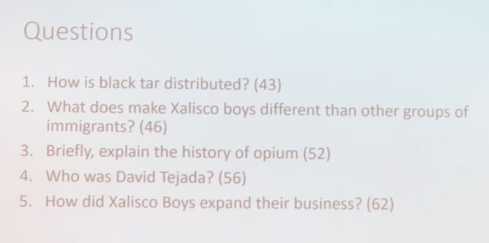
（Read “Dreamland 2.PDF”）

The Second Essay:
QUESTION:
1.Who is “El Gato”?
2.What was the first law that criminalized drugs and sent thousands to jail? (76)
3.What was the CPDD?
4.What is known as “the Holy Grail”?
5.Who was Stjernsward and what was his mission?

（Read “Dreamland 3.PDF”）

